James sager III | Legendary Talent seeking first chance |  | james_sager_pa@yahoo.com
QUALIFICATIONS
I have proof of much of the following, for it is all truth. It will sound like someone of my talent could not exist without getting a first chance at a career. I assure you all of this is truth, none of this is a lie.
Famous Neo-Renaissance Software Architect of many achievements you probably won't believe so proof is supplied where readily available. Tip Top World Class Designer/Coder/Gamer with significant experience in the area of indie game development. Over 150,000 hours of coding, gaming and design combined. Trained like an Olympic champion to be a pro gamer since 1980 resulting in #1 world in skill most every ladder game played online including Starcraft/Warcraft 3/Diablo 2/Command & Conquer 3 /Starcraft2 2v2. No top 10 world pro wanted to face me, I'm on another level. #1 world competitive ladders in the modern era for most hours played, likely played more Atari2600 and C64 than anyone who ever lived as well. Skilled in multiple programming languages and can be better than experts after a day in a new one. Been coding for 41 years, designing for 38. Advanced software architect for long term project stability yet also rapid prototypes. Father of advanced security involved with hacking/counterhacking/anti cheat and original author of Blizzard's cybersecurity & League of Legends Player Tribunal. Father of modern and future Artificial Intelligence and had a hand in designing the UI transition from Newton/Palm Pilots to Smart Phones.
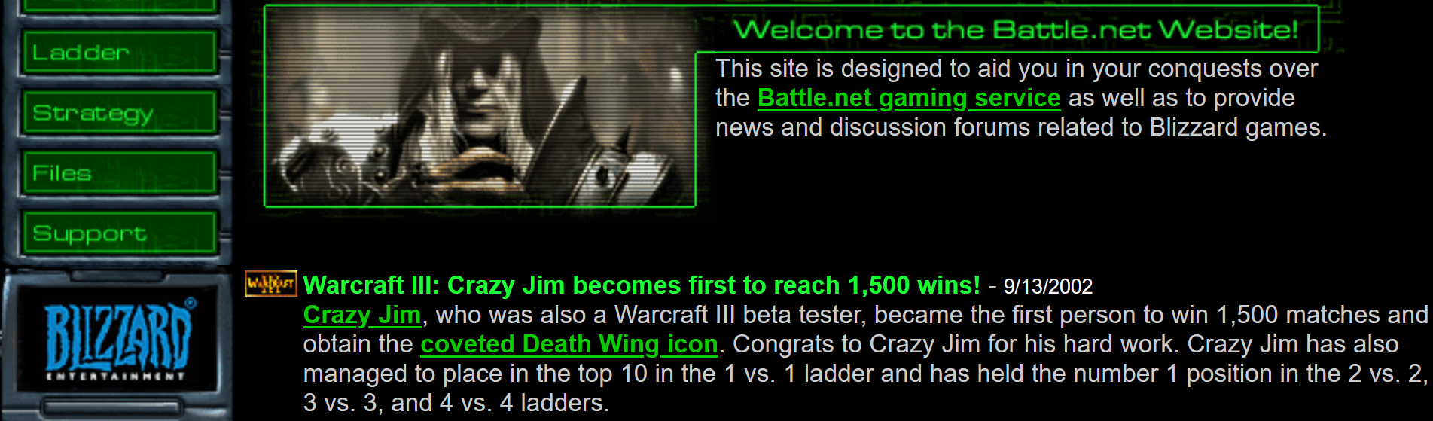
SKILLS
Programming languages: C# 10+ yrs, Java 10+yr, C/C++ 10+yr, Basic 10+yr, Adobe Flash
Platforms: Windows, Linux, UNIX, Mac
Other technologies: ChatGPT,AI Art, Unity3d,Android, iOS, SQL,
Network code innovator, parallel/multithreaded innovator
Knowledgeable on most all aspects of development,
Super fast indexed binary databases
EDUCATION:
Carnegie Mellon University. Graduation: May 2003
B.S. Scientific Computing (CS equiv) / Physics minor
WORK DEVELOPMENT EXPERIENCE:
Tangerine Pop Startup & independent projects
Lead Game Developer / Indie game designer 8/2009 – 2016
- “Dungeon Run Blackroost Keep” Over 4 Million Plays!
- Lead programmer/Associate Designer
- Manually Typed over 70,000 hand written lines.
- https://www.youtube.com/watch?v=Tpa8C8WuiYw
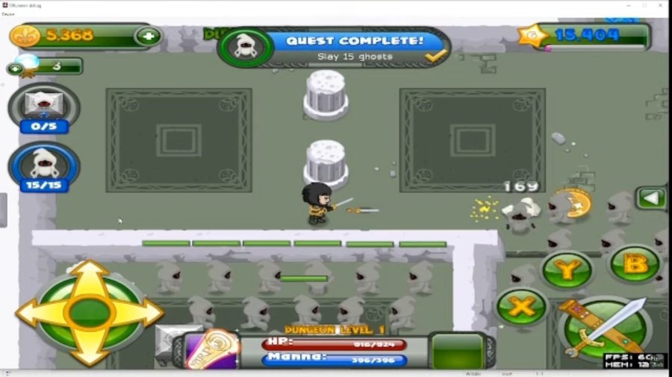
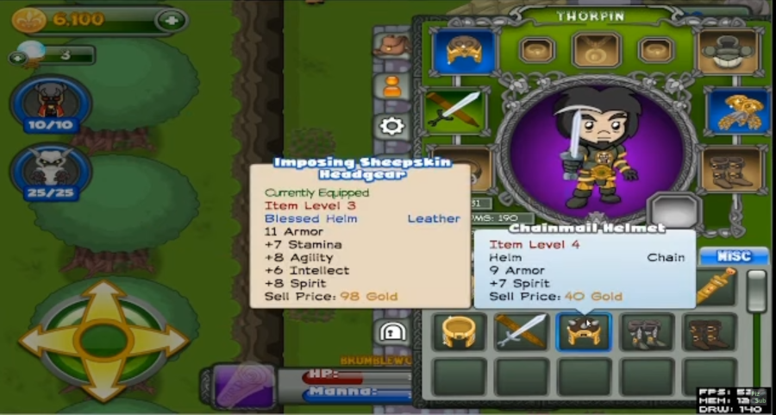
YRU ResearchTech
Programmer 10/2013 – 4/2014&2021-23
- Architect full refactor modernization of legacy code.
- Write software for scientific research devices.
- Learned & Executed techs like USB drivers to circuit boards.
Public Interest Data Incorporated
Programmer 8/2004 – 3/2005
- Developed & Optimized extremely complex single SQL queries
- Debugged in a large unfamiliar code base.

University Accolades:
- 2004: Worked with the first Self Driving Car used in the DARPA Grand Challenge with Red Team Racing. I proposed to use vision recognition on top of the GPS system. Some of the said would be impossible but self driving cars use that now. We all agreed that if it was possible, the time constraints on the Grand Challenge limited it. No one won, but our vehicle traveled the furthest.
- 2002: Father of modern and future AI: General purpose AI such that you see in sci-fi such as 3cpo/Johnny V and I have a business plan to make it self sustaining early on. All you need is vision recognition of your local environment sinceComputer Science has already solved the rest. People disagreed in 2002, but agree today that I was right.
Proof on Internet Wayback Machine:https://web.archive.org/web/20021005054929/http://www.contrib.andrew.cmu.edu/~sager/
They're still not implementing the most important stuff of AI like vision recognition of real world objects, physics simulations of possible outcomes, a central computer to run many simulations and actions to achieve goals with that in mind. It's a lot easier to make a C3PO/Johnny V, Data from Star Trek robot than you'd think. You could get revenue churn in one-two years of box stacking for USPS/UPS/FedEx then go to general purpose factory bots and over decades it becomes a natural progression of updates. This is quite easy actually, no longer difficult to conceive. This is why I filed a registered mail IP to protect it. The future is like MegaMan or Citizen Kane where 'one man' owns all the production in the world. Through that messy transition, it's key to get a trickle of that wealth even if chasing it in the courts.
- 2001: Helped develop hand held User Interfaces before the modern Cell Phone. The first time UI was taught at CMU, the professor came in admitting they knew nothing and opened up to the class for ideas. Studied both the Palm Pilot & Apple Newton. Having 75,000 hours exp at that point, I was able to give more ideas than the entire rest of the class combined. Many of these ideas are now used like smart phones, schedulers, windowing use, and onscreen keyboards instead of unusable gestures.
- 1999 Explained to students/profs how OCR could id license plates for law.
- 1998: Did 20 rocket science problems correctly in my head in a total of 1 minute each while my peers averaged 100 hours on the task and got many wrong.. My peers at Carnegie Mellon often called me the smartest person they ever met which matters since these are some of the smartest people on Earth. Most everyone I meet say I'm the smartest person they ever met and I talk with researchers often.
- 1997: Predicted the Electric Car in despite despite no one agreeing with me at CMU. In the mid 90s did the calculations that Lithium Ion Battery power had more than enough energy capacity to make Electric Cars. All physics students I told disagreed with me, and these are some of the smartest kids in the world. No physics professors agreed. I read history that 1895 cars had reasonable range of like 25 miles with Nickel Cadmium and Lithium Ion had 4-5x the capacity. I reason 5x25 =125 mile range and economy of scale, incremental research, and better manufacturing of 100 years brought that to maybe a 200 mile range.

Personal Indie Projects:
Starfighter General 2018-2023 designed since 1989
- Free on Steam: www.starfighterGeneral.com
- The server was written entirely from the ground up with raw sockets and the Netty Framework. Server & stable reliable for years and over many games.
- Uses new parallel processing 100x the things rendered now. DOTS/ECS pioneer
- Registered mail patent: MMORPG with Networking breaks the rules you know of n^2 connections. I do it in log(n) that on paper allows for over 100,000 of action players in the same zone with half the latency & no server fees :https://www.starfightergeneral.com/2023/08/peer-to-peer-with-server-authority-registered-mail-patent-style-protected-aka-the-infinite-networked-player-algorithm/
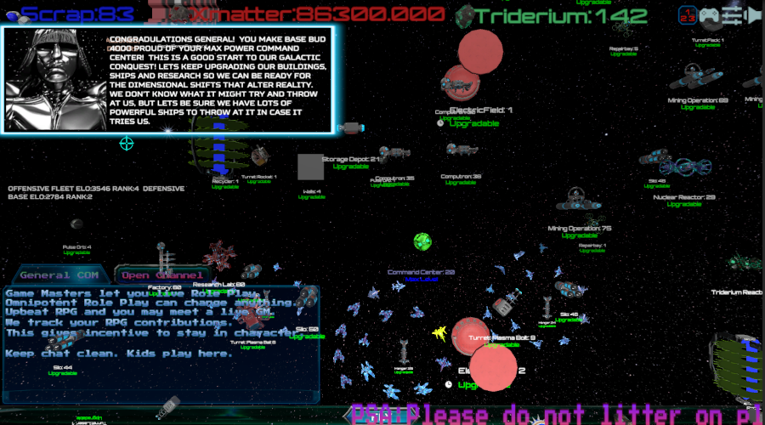
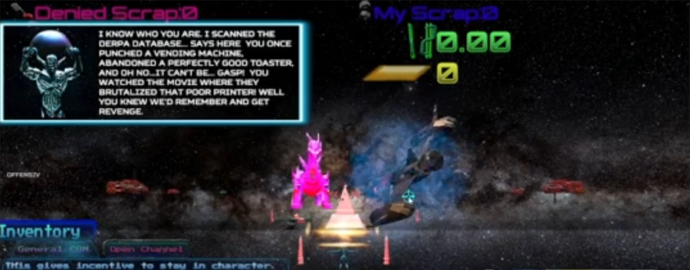

`Battlemon on Android: 2015-2016
- Did this so a Make a Wish kid could say he made a video game.
- Location based experience with puzzles to unravel via geocaching in parks.
- Designed it 9 years before Pokemon Go came out.
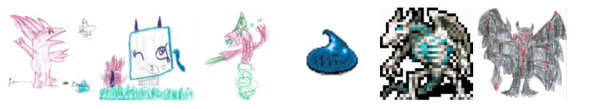
- Knew people would get hurt in GPS games, and if I got sued, I could not defend myself in court so contrary to first mover's advantage, I opted for second mover's concession. Normally they say if you are on the right track but not moving, you get run over, not the case here.
- www.crystalfighter.com/battlemon

Throne and Crown 2013-2014
- Recruited/Managed a team of artists and musicians from Internet.
- Coded all. Did all level design. Did all user interface.
- Acclaimed sound track.
- www.throneandcrown.com
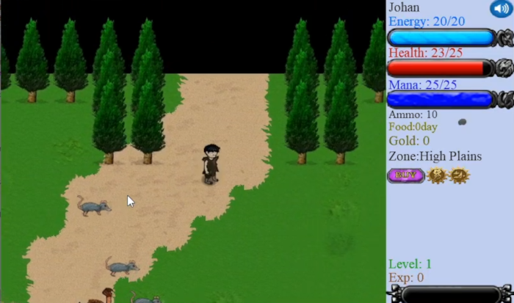
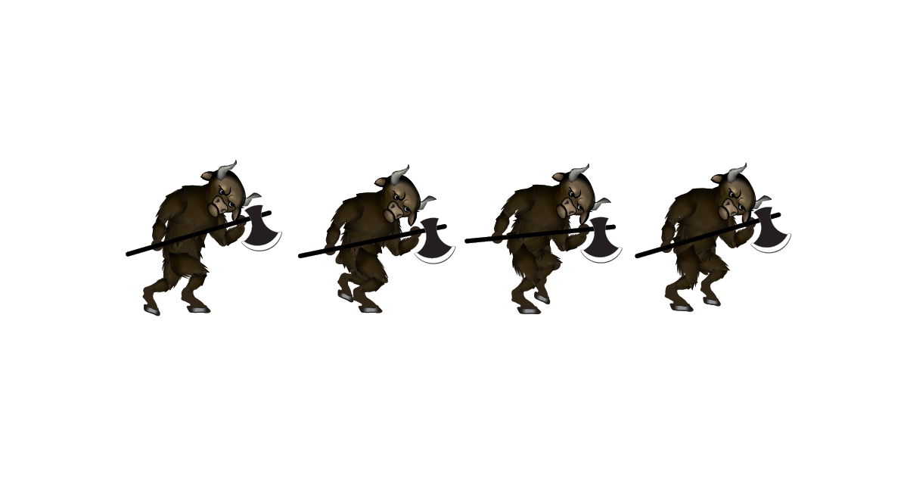
Triangle Mania designed 1999, coded 2009:

- https://store.steampowered.com/app/1062390/Triangle_Mania/


After Juliet in the Pencilvania platformer maker

- Started designing 2019 with 5 year idea arc before coding, coding begins 2024
- Making a Metrodvania in a Metroidvania maker.
- https://www.starfightergeneral.com/2021/12/after-juliet-a-metroidvania-in-dev/
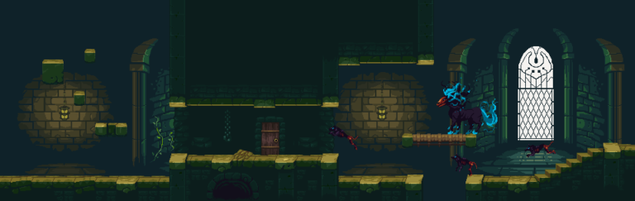

Intergalactic Bounty Hunter: personal live game master teleconferencing software
2017+ Casually playing, and publishing and updating Intergalactic Bounty Hunter. A live game master role playing game suite for online. My friends like playing. With only a few dozen hours work, I could make the world's best GM driven RPG for mechanics like Pool of Radiance but a live GM. https://www.crystalfighter.com/igbh/

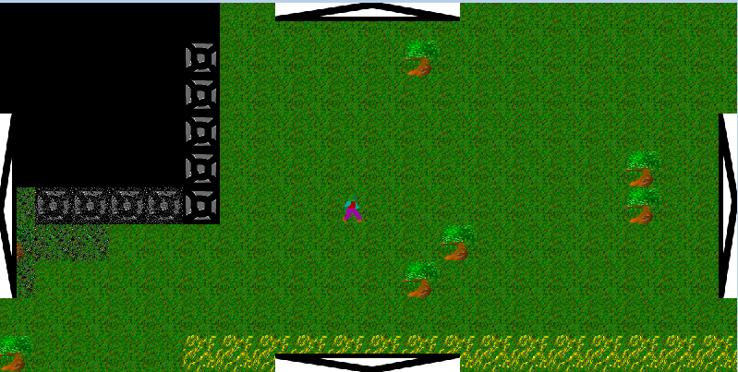
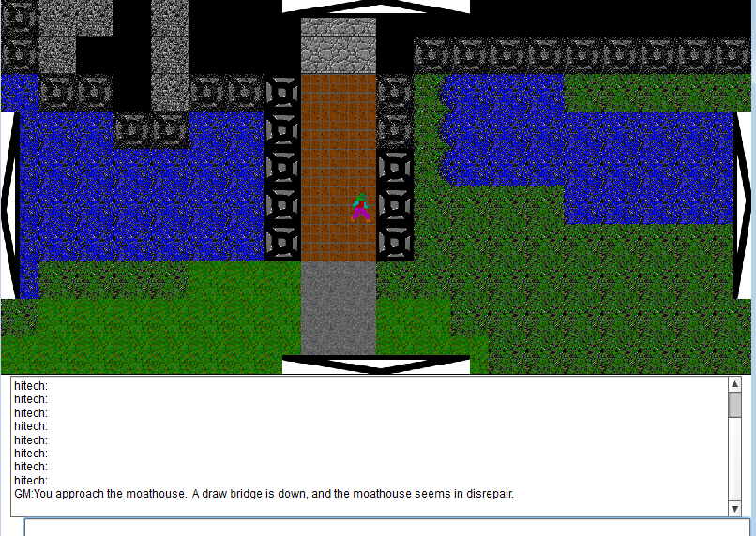

Roaming Dragon/Crystalfighter 2003-2008 on backburner

- A 3d fighter like Tekken,co-discovered rollback code and networking that breaks the rules in an unpublished in house MMO prototype.(my white whale), I am revisiting it in when Animation capture is cheap enough that people can do live Kungfu actions at home. I made Starfighter General recently to stress test my research level networking code before doing complicated 3d animations where people make their own moves again: https://old.reddit.com/r/CrystalFighter/
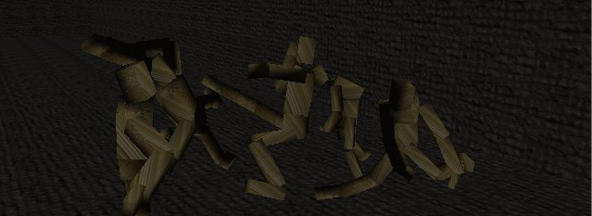
- 2003 When I was a Blizzard friend for being a top player, I balanced TFT to allow for more pvp engagements. I told Blizzard to reduce gold creeps give so the game is less pve and become more pvp. They agreed. My system did as I told them it would. TFT is widely hailed as good.
- 1992-1998 Tried to make the world's first MMO in using Quick Basic! I had to write an interpreted language to access the 200 meg hard drives of the era to get past the 640k memory limits and lots of it was scripted. I did this when I was 15 yrs old. I quit making it when Ultima Online came out because their graphics were superior. I knew even then there was room for only one king MMO. It was good because I got #1 world Starcraft skill in all races
https://web.archive.org/web/20041001082652/http://www.geocities.com/james_sager2/
- 1993 I emailed Westwood when they had Dune II, and told them,”Add regenerating spice and multiplayer and you'd have a hit.” You can see I was right with the Command and Conquer franchise. I knew RTS was the future of pro gaming so I over-practiced Dune II past fun.
Free Consulting:
- 2022 Free UI consultation for Ebay 2022. Hundred+ emails. Totally impressed them: https://www.youtube.com/watch?v=jJV4xw2Q7I8&list=PLOQ-J23AJUfR-P3cgpL8XFtem6aOzd7Ao&index=2
- 2018: Told google Ads UI poor. Only needed one url+click. They had like 20+ fields and confusion clicks. They issued redesign, but did not take my advice.
- 1999: Was the inventor of Buy It Now button of Ebay in 1999 by forcing their hand as a seller,”Offer me x$ and I end the auction early. Ebay needs to make this an official feature or will never collect fees from me when I do this.” I did this for honesty sake.
Life Achievements:
- 2002-2003 #1 USEast(& world) 1v1,2v2,3v3,4v4 Warcraft3 2003. First to 1500 wins in Warcraft3. Went 200-0 in 3v3. Played Random aka all races
- 2000-2001 Father of bots/Macros in Asheron's Call 1, I even used OCR to make bots that could read the navigation numbers and cycle in patrol routes. Made 800$/month selling bots and in game loot.
- 2000 #1 experience in the world in Diablo2 Hardcore on three different accounts!
- 2000 Redesigned Angband against great forum resistance to add Auto Squelch(ignore items on ground not concerned with). David T. Blackston coded my system, now everyone agrees the game would be unplayable without it. PROOF is on Usenet still: https://groups.google.com/g/rec.games.roguelike.angband/search?q=james%20Sager%20squelch The importance of this is major since Angband vs Nethack is a classic nerd argument up there with Kirk vs Picard. They disagreed, said it'd break the game or be useless. Now everyone says Angband is unplayable without this component.
- 1999 Favorite to win in 1999 Blizzard Broodwar World Championships, but some dude admitted he cheated that beat me. Xds'Grr(the first Korean Pro winner), I won vs easily every time I played him. He said I had to be cheating. I told him he was #2 on Earth, because he has some semblance of how to actually play, but I was so much better than him it was like Michael Jordan vs a Jr Varsity Jr High school player. Many other top 10 players told me they never wanted to play me ever again. I wasn't just #1 world in skill at these games, I was tiers above the top 10 players in the world.
- 1999 #1 in world for Broodwar 1999 All Races : Zerg/Protoss/Terran
- 1998-99 #1 in world for Starcraft Vanilla All Races : Zerg/Protoss/Terran
- 1993 Something quite unbelievable, but I have proof for this too: idea man behind The Pinky and The Brain: https://www.starfightergeneral.com/2021/12/meet-the-paraplegic-mice-team/
- 1989 #1 Qualifier in Pittsburgh 1989 Nintendo World Championships
- I've invented many things before others have knowing the viability of them, but not having a team to execute. After reading about CompuLink in about 1985 at age 8 knew MMOs would come about. Saw the market for a Castlevania game with armor/weapons and leveling in 1989. Designed instant messaging on Windows before it existed. Designed dating websites before they existed. . Thought of a marketplace like eBay using USENET and only months before eBay forms. In a Westinghouse conference for high school students, I heard the difficulties the military had making self driving ATV drones and I thought of a beamed internet system to control em manually with encryption based on angle of the EM wave. Then I realized it needed a timing sequence, so I thought of a network of satellites that could give position to the ATV. I 'co-discovered' GPS before it was a public knowledge thing. Knew self driving car would be good, but we had technology for smart rail/trolleys since the 70s we could be transporting people/goods we should be using now. Riot's old anti-cheat known as Player Tribunal used to be called Player Policing, a system I sent to Blizzard to combat hacks/win trading in 1999 Battle.net. Todd Cadwell brought it with him to RIOT. This is not remotely a full list of things I co-discovered or knew before they came out and just didn't have a team. My friends joke that I come up with so many multimillion/billion ideas that I need a website to keep track of em all.
- Order of the Arrow Eagle Boy Scout

More proof of my old fame online:
https://games.slashdot.org/story/05/02/10/0534217/nyt-on-world-of-warcraft?sdsrc=prev
Scroll to cesare's comment:
https://www.fark.com/comments/389978/Warcraft-III-is-best-game-of-year?startid=2635551
This one said I dominated early on. Yes, no one could beat me so no reason to keep playing:
https://www.wcreplays.com/forums/archive/index.php/t-130092.html
Known as a GOSU of Starcraft: (search for crazyjim)
https://tl.net/forum/brood-war/51077-remembering-the-forgotten-gosus

